Feedback for v1.307

Overall
- On the privacy matter, my concern is with the Load folder showing saved names as other clients will be able to see this. Perhaps, we can move this to settings or hidden somewhere so that only I have access to it?

Client Details
- I agree that the Cashflow Projections are assumptions, however I’d like them on the Projections page to avoid having to toggle back and forth between the Projections and Client details page when presenting and changing assumptions
- I’m not too sure how you’ve formulated the Group Constraint – let me know how to use it properly

Optimisation
- Let’s move the Forecast Confidence button to settings
- Under what circumstances should I use each of the Low, Medium and High Forecast Confidence?
- The efficient frontier (ie portfolios) doesn’t seem to align with the clusters which I assume are the outcomes of the simulations. This doesn’t make sense. The efficient frontier should be the average of the simulations. I would expect more something like the below in red – and then the portfolios are derived from the lowest to the highest point. Have I missed something - what do you think?

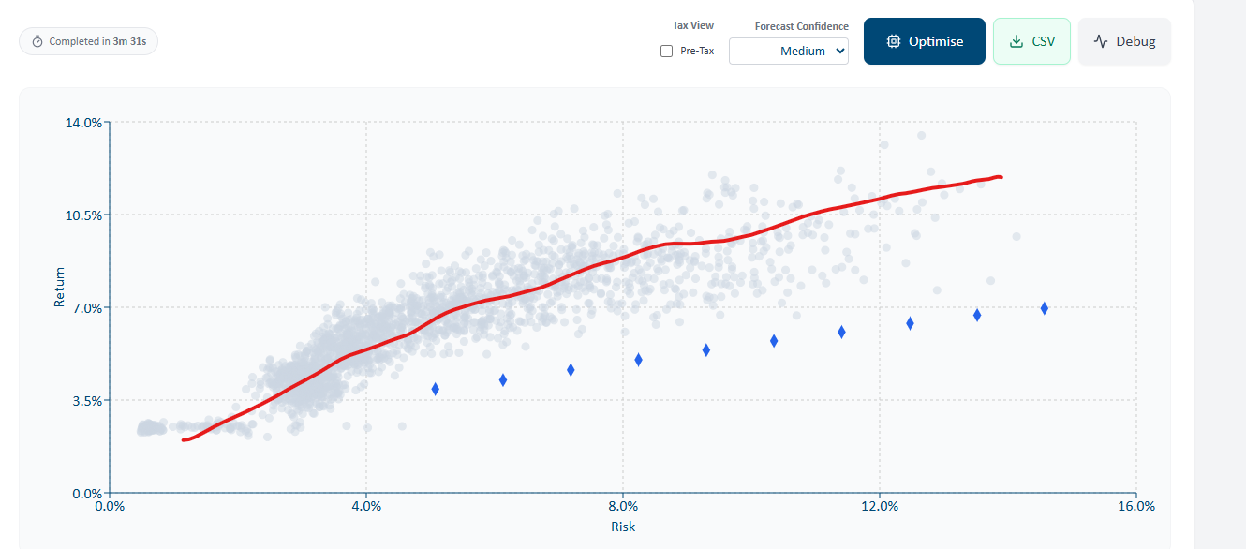
- Please remove the “Completed in” box

Output
- The portfolios have names again. Please revert these back to 1 -10
- There is now the opposite problem with portfolio 1 because the return and risk are far too high. Should be delivering ~ 3% return and 1% risk
- When I ran a two or three-entity scenario and applied a constraint to cash, it didn’t adhere to it – same problem exists
- Please restore the pie charts per entity to show each asset class. Just the overall pie chart should be grouped
- Can we use a less orange and more blue colour palate for the pie charts

Projections
- Yes you are right, an overlay of the pre-tax for the wealth projection chart would be great – please add this
- See attached re: how to calculate standard deviation and inflation

